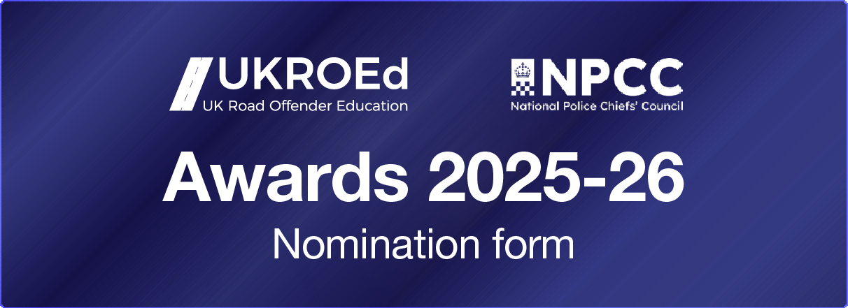

UKROEd/NPCC Roads Policing are seeking nominations for the following awards (all nominations should be received before end of Friday 14th August 2026):
UKROEd Award Categories
- Outstanding Team Contribution to the NDOR Scheme
- The Dave Jones Award for Outstanding Contribution to NDORS
- Outstanding Contribution to Diversity & Inclusion
NPCC Roads Policing Categories
- Outstanding Contribution to Road Safety
- Innovation and Excellence
- Front Line Hero of the Year – Roads Policing
Name and rank or role of nominee
Nominating person name and rank or role
Which award you are nominating for
Name and rank or role of line manager / supervisor endorsing this nomination and brief comments
Police Force/Organisation

Date of nomination
Please provide concise and relevant evidence, or information, as to why you believe the person you have nominated deserves the award you are nominating them for. Please describe exactly what they did and how they did it.
Where possible be specific about how their work impacts on future performance or best practice, why their work was ambitious, how they recognised what works well or how they have influenced others, or policy and procedure.
(Must be typed in Arial font size 12 and no more than 600 words)

These Awards have been created to recognise fundamental roles within our business and to acknowledge those that perform and demonstrate the best qualities of and/or support the role through their committed efforts.
It is intended to recognise individuals/teams who, in the judgement of the UKROEd/NPCC Roads Policing Panel, have demonstrated an outstanding contribution in the above fields. This may be in the capacity of strategic thinking or professional development, as well as operational duties.
The Awards shall be open for nominations from Monday 11th May 2026.
Please note any nominations received after Friday 14th August 2026 cannot be considered.
A nomination should include details of the nominated party and the evidence that meets the criteria for the award on our application form (maximum of 600 words). The nominees can be from any of our key business areas/stakeholders.
On Thursday 3rd September 2026, members of the UKROEd/NPCC Roads Policing Panel shall meet to examine, discuss, and judge the nominations to select winners of the awards. The winning recipients will then receive notification of their award and will be invited to attend a special 2025-26 Awards Ceremony at the UKROEd/NPCC Roads Policing Conference at the Radisson Hotel/Manchester Airport on the evening of Wednesday 14th October 2026. Winners will be invited to stay for conference dinner, the awards ceremony and will be offered accommodation for the evening where required.
The judgement of the UKROEd Panel in selecting the recipients will be final and there is no appeals process to challenged decisions.
All applications should be submitted in confidence by email to: stakeholder.engagement@ukroed.org.uk

